Project Design Phase-II
Data Flow Diagram & User Stories

Date | 31 January 2025
Team ID
Project Name | Cab Booking
Maximum Marks | 4 Marks

Data Flow Diagrams:
A Data Flow Diagram (DFD) is a traditional visual representation of the information flows within a system. A neat and clear DFD can depict the right amount of the system requirement graphically. It shows how data enters and leaves the system, what changes the information, and where data is stored.
Example: DFD Level 0 (Industry Standard)
Example:
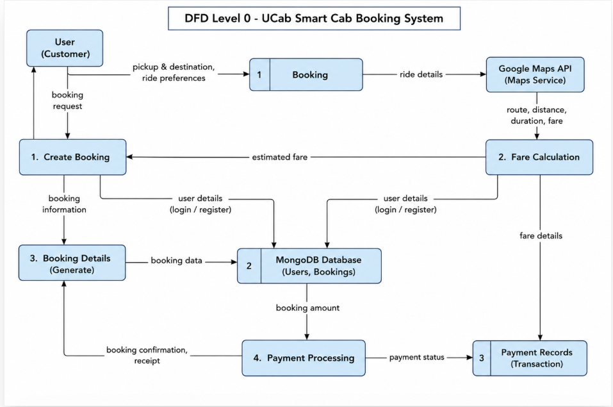
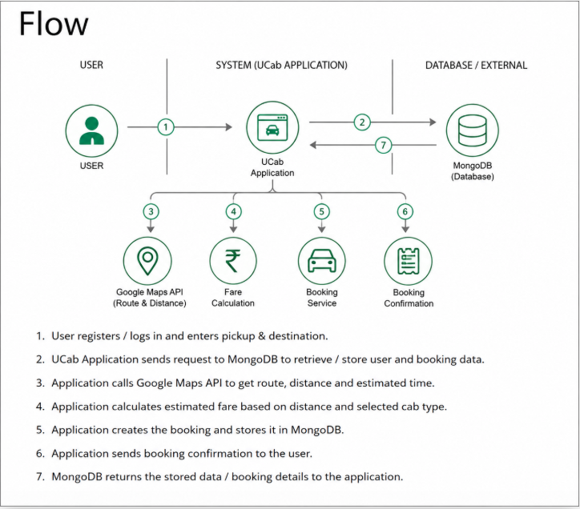

User Stories
Use the below template to list all the user stories for the product.

User Type | Functional Requirement (Epic) | User Story Number | User Story / Task | Acceptance Criteria | Priority | Release
Customer (Mobile/Web User) | Registration | USN-1 | As a user, I can register in the application using email and password | I can successfully create an account and access the system | High | Sprint-1
Customer (Mobile/Web User) | Login | USN-2 | As a user, I can log into the application using email and password | I can securely access my dashboard after login | High | Sprint-1
Customer (Mobile/Web User) | Booking Ride | USN-3 | As a user, I can book a cab by entering pickup and destination | I can successfully create a booking request | High | Sprint-1
Customer (Mobile/Web User) | Fare Calculation | USN-4 | As a user, I can see estimated fare before confirming booking | System shows fare based on distance | High | Sprint-1
Customer (Mobile/Web User) | Booking History | USN-5 | As a user, I can view my past bookings | I can see all previous ride details | Medium | Sprint-2
Customer (Mobile/Web User) | Cancel Booking | USN-6 | As a user, I can cancel my booking | Booking status updates to cancelled | Medium | Sprint-2
Customer Care Executive | Support | USN-7 | As support staff, I can view contact queries | I can respond to user queries | Low | Sprint-2

